2023 Partner Toolkit

–––
INTRODUCTION

Dear Partner,

Healthcare workers’ mental health matters. Because when doctors, nurses and other healthcare professionals take care of their mental health, they are best able to care for patients.

As part of our efforts to support healthcare worker well-being, in 2022, the Ohio State Medical Association and OSMA Foundation introduced Well-Being CARE – a free, anonymous tool to screen for mental/emotional health issues and if needed, connect with licensed mental health professionals.

We need your help spreading the word to ensure every healthcare provider in the state knows how to access CARE if they need it, when they need it.

With more than half of healthcare professionals reporting symptoms of burnout, the need for this type of service has never been higher.

Below is a toolkit to help you share information about Well-Being CARE through email and social media. As a thank-you for being a CARE partner, we will post your logo as a supporting partner on wellbeingcare.org, and include you in future communications about CARE with partners statewide.

Well-Being CARE Service is made possible through partnership with the Ohio Physician Health Program and the American Foundation for Suicide Prevention.

–––
SOCIAL MEDIA POSTS

Healthcare workers’ mental health matters. Take the free and confidential Well-Being CARE Service survey to check up on your mental and emotional health and discover helpful resources. Wellbeingcare.org

Ohio Healthcare Workers: Have you heard about the Well-Being CARE Service? It’s a free and anonymous tool to help you assess your mental health and discover helpful resources should you need them. Visit wellbeingcare.org to get started.

Healthcare worker burnout is real, but so are the resources to help. The Well-Being CARE Service is a free, easy-to-use tool to help you check up on your mental health and – if needed – confidentially connect with vetted support services. Learn more at wellbeingcare.org.

XX healthcare workers in Ohio visited the Well-Being CARE Service in 2022 to check up on their mental and emotional health. Join them and take the confidential assessment today: wellbeingcare.org

HASHTAGS TO TAG

#CAREforHealthcare
#OhioCARE
Wellbeingcare.org

SOCIAL POST GRAPHICS

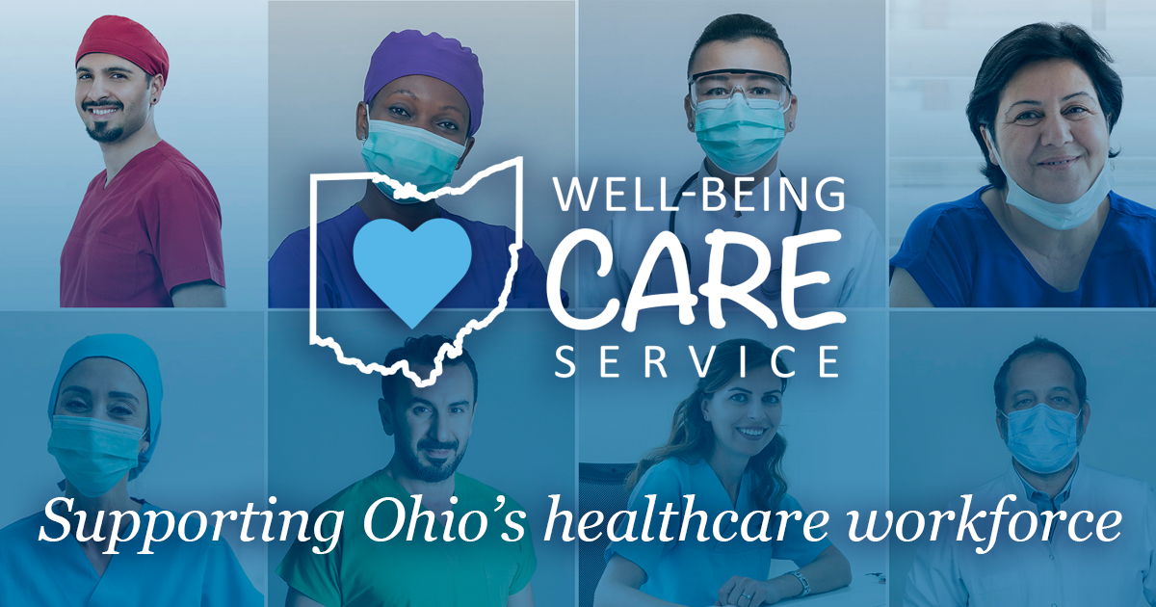
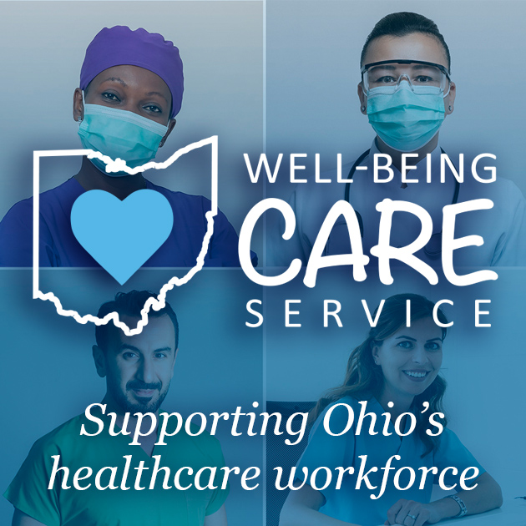

–––
EMAIL BLURB

As healthcare providers, we know caring for our physical and mental health helps us stay at the top of our game. But often the demands of practicing medicine, family and life in general can get in the way – especially when it comes to prioritizing mental and emotional health.

But at [Organization Name], we want our team to feel empowered to care for your mental well-being, especially if you are feeling increased levels of stress, depression, anxiety or burnout.

Ohio’s Well-Being CARE Service is a free tool just for Ohio licensed healthcare workers to take a quick assessment and if needed, connect with vetted mental health resources.

All participation is anonymous and completely voluntary.

The need is clearly there – since its launch in May 2022, thousands of Ohio healthcare workers have visited wellbeingcare.org.

“I’m excited the Well-Being CARE Service is built truly with the needs of healthcare workers in mind. Healthcare workers have for a long time needed mental health resources that we can access confidentially.” ~CARE user

Well-Being CARE is powered by the Ohio State Medical Association Foundation. Visit wellbeingcare.org to get started.

