2022 Partner Toolkit

–––
INTRODUCTION

Dear Partner,

When it comes to healthcare professionals, it is important to all of us that doctors, nurses and other healthcare workers take care of their mental and physical health.

And as the COVID pandemic and other factors continue to stress the healthcare system, physician and healthcare worker burnout is quickly becoming an epidemic in the healthcare community.

The Ohio State Medical Association, and our philanthropic arm the OSMA Foundation, are introducing the Well-Being CARE Service to all licensed medical professionals in Ohio. Through this free, anonymous tool, healthcare workers can:

- Take a brief survey to screen for mental health conditions
- Receive a personal response from a licensed counselor and connect to licensed mental health professionals, if needed
- Receive recommendations for vetted mental health services in their community

The Well-Being CARE Service is available to any licensed healthcare provider in Ohio, as well as those in medical school or licensed healthcare training programs.

We need your help in spreading the word to ensure every healthcare provider in the state knows how to access CARE, and knows how important it is to prioritize their mental well-being.

Below is a toolkit to help you share information about the Well-Being CARE Service through email and social media. As a thank-you for being a CARE partner, we will post your logo as a supporting partner on wellbeingcare.org, and include you in future communications about CARE with partners statewide.

Well-Being CARE Service is made possible through partnership with the Ohio Physician Health Program and the American Foundation for Suicide Prevention.

–––
SOCIAL MEDIA POSTS

If you’re feeling burnt-out, stressed or depressed in your healthcare job, you’re not alone. Use Ohio’s Well-Being CARE Service to assess your mental health and discover helpful resources. Wellbeingcare.org

The Well-Being CARE Service is a free, anonymous and easy tool for Ohio’s healthcare workers and healthcare workers in training to check up on their mental health and connect with vetted support services. Complete this 10-minute questionnaire to get started: wellbeingcare.org

The Well-Being CARE Service is available to all Ohio healthcare workers and those in training at no cost and provides an easy, anonymous way to connect with vetted mental health resources. Learn more at wellbeingcare.org.

May is Mental Health Awareness Month, and there’s no better time for healthcare professionals to check up on their mental health. Ohio’s Well-Being CARE Service is free, anonymous, and easy to use. Learn more at wellbeingcare.org.

HASHTAGS TO TAG

#CAREforHealthcare
#OhioCARE
Wellbeingcare.org

SOCIAL POST GRAPHICS

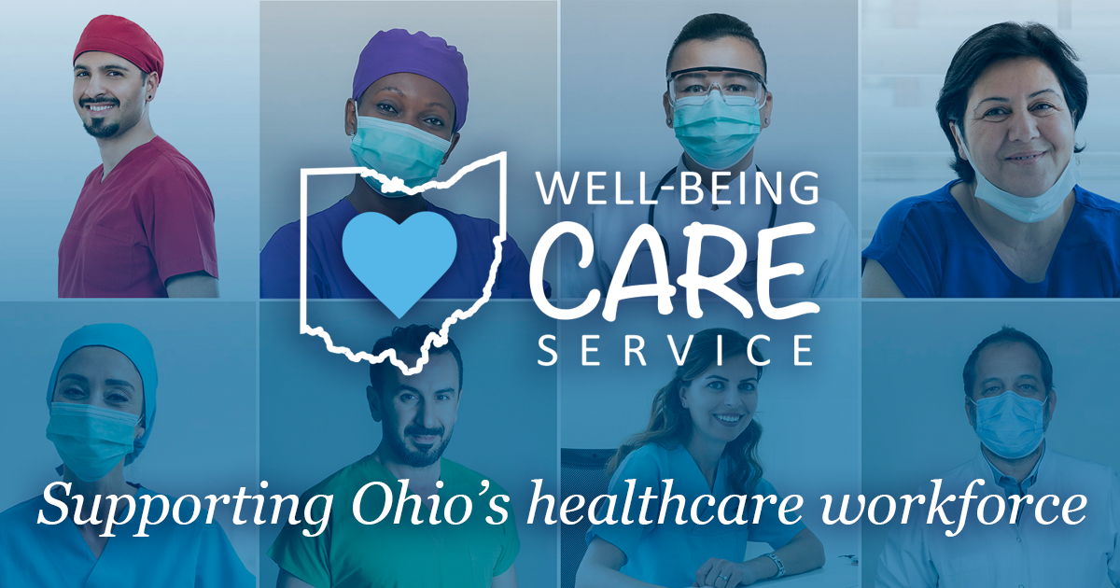
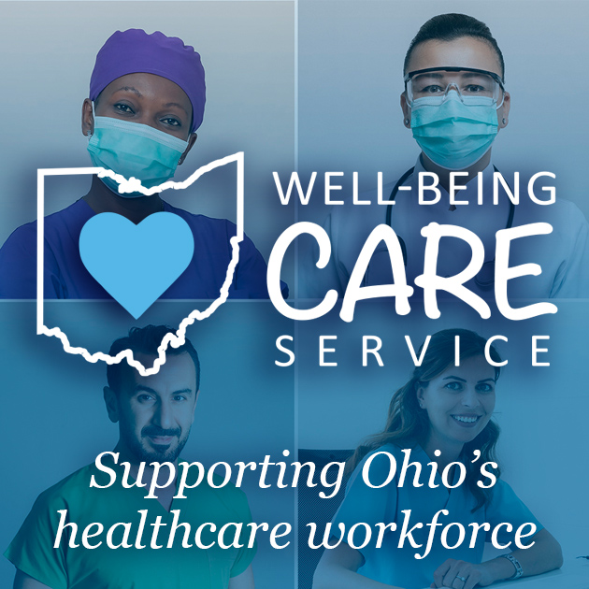

–––
EMAIL BLURB

Feelings of stress and burnout impact all of us. For many healthcare professionals, stress, burnout, and mental/emotional health issues are at an all-time high. Especially, during the past two years of the COVID pandemic plus other issues and strains on the US healthcare system.

Here at [Organization Name], we are here to support the well-being of you and healthcare workers throughout the state of Ohio.

If you are feeling increased levels of stress, depression, anxiety, burnout, or other mental or emotional distress, we encourage you to take advantage of Ohio’s Well-Being CARE Service.

This free, anonymous tool is available to all Ohio licensed healthcare workers and those in training, providing a quick and easy way to assess your current state of mental health and well-being, and connect with personalized recommendations and vetted mental health resources, should you decide to take further action.

All participation is free, anonymous, and completely voluntary. To learn more, visit wellbeingcare.org.

